المملكة العربية السعودية

وزارة التعليم

جامعة الباحة

كلية الحاسبات والمعلومات

قسم النظم والشبكات

Kingdom of Saudi Arabia

Ministry of Education

Al-Baha University

Faculty of Computing and Information

Department of Systems and Networks

**Final Year Project Report**

المملكة العربية السعودية

وزارة التعليم

جامعة الباحة

كلية علوم الحاسب وتقنية المعلومات

لجنة مشاريع التخرج

Senior Project for CIS 1

CRN: 32517

Submitted in partial satisfaction of the requirements for the

Degree of Bachelor’s in Computer Information Systems

*Entitled:*

**Ather graduated**

**Computer Information Systems**

**Al-Baha University**

*Undertaken by:*

Aseel Ateeq 444017590

Arwa Abdullah 444015565

Haneen Abdullah 444017158

Norah Mohammed 444018426

Raghad Ahmed 444017135

*Supervised by:*

Mohammed Idris

Month 2025

# Project Brief

Project Name Ather graduated System

Department Name /* Dpt. Name */

Undertaken By

/* Student 1 Full Name */

/* Student 1 Full Name */

/* Student 1 Full Name */

Supervised By /* Supervisor Name */

/* Designation */

/* Department Name */

/* University Name */

Started on /* Start Date */

Completed on /* End Date */

Computer Used hp

Operating System /* Name of OS */

Tools Used /* Names of Tools */

# Acknowledgements

We would like to acknowledge this work to ....

# Dedication

*We would also like to dedicate this project to*

*………*

# Abstract

Creating an online platform to manage academic and professional obligations is the goal of this project, Faculty members(professors) and students can request recommendation letters. The current procedure for Requesting and composing letters of recommendation is frequently chaotic, time-consuming, and ineffective since it usually depends on unofficial communication and has no centralized system, Problems like ambiguous requirements, overlooked requests, and poorer quality result from this. Recommendations as a result of incomplete information.

The suggested remedy is the development of an electronic platform that enables students to send in structured requests for recommendations and gives faculty members the resources they need to efficiently handle and reply to these requests.

Among the features of the system will be customizable templates, intelligent forms that gather comprehensive student data, and a tracking system to keep tabs on the progress of every request. Additionally, user authentication will be incorporated to guarantee safe communication between instructors and students.

The project's intended contributions include enhancing the professionalism and quality of recommendation letters, lowering the workload for faculty, and guaranteeing a more structured and transparent communication process. In general, the project aims to improve the recommendation experience and assist students in reaching their academic and career goals. The project's target users are university students looking for academic or professional recommendations and the faculty members who write them.

# Table of Contents

Project Brief 1

Acknowledgements 2

Dedication 3

Abstract 4

Table of Contents 5

List of Figures 7

List of Tables 0

Chapter I INTRODUCTION 1

1.1. Background and Motivation 1

1.2. Problem Definition 3

1.3. Aim and Objectives 4

1.4. Proposed Solution to Problem 5

1.5. Scope and Domain 6

1.6. Project Management Plan 6

1.7. Outline 7

Chapter 2 LITERATURE REVIEW 8

2.1. Introduction 8

2.2. Similar Studies 8

Chapter 3 Feasibility Study 12

3.1. Introduction 12

3.2. Operational Feasibility 12

3.3. Technical Feasibility 13

3.4. Economic Feasibility 14

Chapter 4 SYSTEM ANALYSIS 15

4.1. Software Development Methodology 15

4.2. Stakeholders Identification 15

4.3. Requirements Gathering and Analyzing 16

4.4. Summary 26

Chapter 5 System Design 28

5.1. Detailed System Design and component descriptions 28

5.2. Database Design 28

5.3. User Interface Design 28

5.4. Summary 28

Chapter 6 Implementation and Testing plan 29

6.1. Implementation Plan 29

6.2. Testing Plan 29

6.3. Summary 29

Chapter 7 Conclusion 30

7.1. Introduction 30

7.2. Future Work 30

List of References 31

Appendix A 32

# List of Figures

Figure 1 6

Figure 2 10

Figure 3-class 19

Figure 4-use case 20

Figure 5 29

Figure 6 29

Figure 7 30

# List of Tables

Table 1 13

Table 2 Economic Feasibility – Software Requirements Costs 14

Table 3 Economic Feasibility – Hardware Requirements Cost 14

# Chapter I INTRODUCTION

## Background and Motivation

Background:

The production of a series of documents that demonstrate a student's credentials and abilities has become more and more necessary in recent years for students applying to academic and professional programs; the recommendation letter is one of the most crucial of these.

Receiving organizations, including colleges, companies, or scholarship committees, utilize these letters as an essential tool to get an unbiased opinion of the applicant from a scholar who is familiar with the candidate's traits, abilities, and capabilities.

Particularly when they are properly produced and published by a reliable source, they become even more significant in competitive settings where they may be the deciding element in choosing one applicant over another.

Notwithstanding the changes in education, including the transition from conventional to digital models, As far as recommendation systems are concerned, many educational institutions continue to use antiquated techniques.

Requesting a recommendation usually requires the student to speak with the faculty member in person or send an email.

The professor is forced to ask for more information or write a generic, non-specific letter as a result of these requests, which are frequently haphazard and lacking in essential data, diminishing their worth. Furthermore, faculty members now have a heavier workload than ever before due to the growing number of students and the diversity of their academic and professional objectives. They must handle a high volume of requests in a brief amount of time while upholding excellent writing and content standards.

This demonstrates the pressing need for an intelligent and trustworthy digital platform that can streamline the entire procedure, from making the request to providing the recommendation, all the while guaranteeing privacy, quality, and usability.

Motivation:

When graduate students apply for jobs, graduate programs, or scholarships, they must include letters of recommendation. However, the procedure for making and handling recommendations is frequently chaotic and disjointed, taking a lot of time and energy from both instructors and students.

It is challenging for academics to efficiently monitor and handle the numerous recommendations requests they receive through email and live chat. This misunderstanding may result in missed requests or delayed responses, which would be detrimental to the pupils. On the other hand, students find it difficult to make professional requests for recommendations since they don't have a clear way to monitor the progress of their requests or make sure they are turned in on time. Delays or a lack of excellent recommendations may result in lost academic and professional chances.

In order to address these problems, the Athar Graduate Website offers an integrated e-system that makes it easier for students to submit recommendation requests in a structured and expert way and makes it simple for instructors to oversee and monitor requests using a single platform. By automating the procedure, the system greatly minimizes needless back-and-forth communication and delays, hence addressing time problems.

Additionally, the platform supports contemporary trends in environmentally conscious digital transformation by reducing the usage of paper and conventional manual processes, which helps to improve sustainability. Authentication and data integrity are also given top priority by the system, guaranteeing that all requests and suggestions are safely made and validated in a reliable setting.

This solution will streamline the procedure, lessen administrative workloads, and guarantee that recommendations are issued promptly and effectively. It will also enhance the caliber of communication between instructors and students and foster an academic climate that is more dependable and prepared for the future.

## Problem Definition

When trying to get a recommendation letter from a professor, many students encounter persistent difficulties, particularly when applying for academic or professional opportunities. These challenges frequently start with the student's inability to choose the best professor to write the letter, especially if there hasn't been much communication or academic ties between them. A weak or generic recommendation may result from this unfamiliarity. Further complicating matters is the lack of a defined procedure or specific website for requesting recommendation letters. Frequently, students are puzzled about the specific requirements, such as whether the recommendation should be academic or professional, as well as the appropriate format and kind of information they should provide. Miscommunication could ensue, and the procedure might be hampered or postponed as a result.

Students' propensity to put things off is another prevalent problem. A lot of students put off submitting their requests until the last minute, which puts a lot of time strain on the lecturer. The letter's quality may suffer as a result, and the student may miss crucial application deadlines in certain situations. Sometimes, because the student does not supply enough background information, such as accomplishments, abilities, or academic record, the suggestions are ambiguous or shallow. A professor who does not know the student well may make endorsement seem impersonal, which lessens its significance.

Another factor is psychological barriers. Because they are afraid of being rejected or because they don't want to bother the professor, many students are reluctant to ask for recommendations. They may be unable to pursue a worthwhile chance that could greatly advance their academic or professional goals as a result of this hesitancy.

The absence of a single resource that compiles all the material required for recommendation letters is another reason why many student’s struggle. There isn't a clear platform that offers instructions, templates, or samples to help students understand what should be in a letter, how to request one, or even how to get in touch with academics. Because of this lack of resources, some students become confused and don't know where to begin, which leads to requests that are either poor quality or incomplete. For both students and instructors, a platform that provides unified, organized information would streamline the process and save time and effort.

Furthermore, students may find it difficult or inconvenient to reach teachers, particularly in large colleges or programs with a large student body. There are frequently few office hours, and some instructors don't offer chances for interaction outside of class. Strong academic ties are essential for obtaining persuasive recommendation letters, and this barrier lessens the likelihood of establishing them. Additionally, some students only use email, which might hinder communication and reduce the possibility of getting prompt answers or sufficient assistance.

## Aim and Objectives

**Aim :**

To offer a well-structured and effective platform that makes it easier for graduate students to request letters of recommendation while assisting instructors in efficiently handling and monitoring requests.

**Objectives:**

1. Enable students to request letters of recommendation in a professional and organized manner.
2. Provide a simplified system for professors to manage requests and easily approve or reject them.
3. Reduce the time and effort required by both parties by limiting random and unorganized communication.
4. Ensure the confidentiality and security of letters of recommendation.
5. Improve students' chances of receiving strong and reliable recommendations when applying for jobs, graduate studies, or scholarships.
6. Enable students to easily and clearly track the status of their applications.
7. Promote professional communication between students and professors through a formal.

## Proposed Solution to Problem

The proposed solution for this project is to develop an intelligent and integrated online platform (Athar Graduate) that simplifies and organizes the process of requesting and writing academic and professional recommendation letters between Graduate and faculty members. The platform is designed to address the common challenges faced by both parties by automating the workflow and providing a streamlined, efficient environment that ensures the quality and timeliness of recommendations.

Through the platform, graduating students will be able to submit official recommendation requests by filling out a detailed form that includes their academic background, resume ,goals, and information about the institution or company they are applying to.This request is then sent directly to the selected professor in an organized and professional manner, with tracking features available to monitor its status.

On the professor’s side, Using a customized dashboard, the lecturer will be able to view incoming requests with ease. The platform will include intelligent tools, including editable templates, to enable them to quickly and effectively create customized recommendations without having to start from zero.

Additionally, the system will have a reminder feature that will automatically notify instructors of outstanding requests and impending deadlines, guaranteeing that no recommendation is missed or postponed

Putting this idea into practice makes the suggestion process less time-consuming, more structured, and more professional. It lessens the workload for teachers and greatly raises the caliber and efficacy of the recommendations that students receive, which eventually increases their chances of getting into master or finding employment.

## Scope and Domain

Scope:

The project includes the design and development of an electronic platform that enables graduating students or those about to graduate to request academic or professional recommendations from faculty members in a professional and organized manner.

The platform also provides smart tools to facilitate the efficient and quick preparation of recommendations by professors, along with the ability to save and track the status of these recommendations.

Domain:

The proposed solution is to design a digital platform that allows students to submit complete recommendation requests and enables faculty members to easily prepare recommendations using smart templates. This accelerates the process and enhances its quality for both sides.

## Project Management Plan

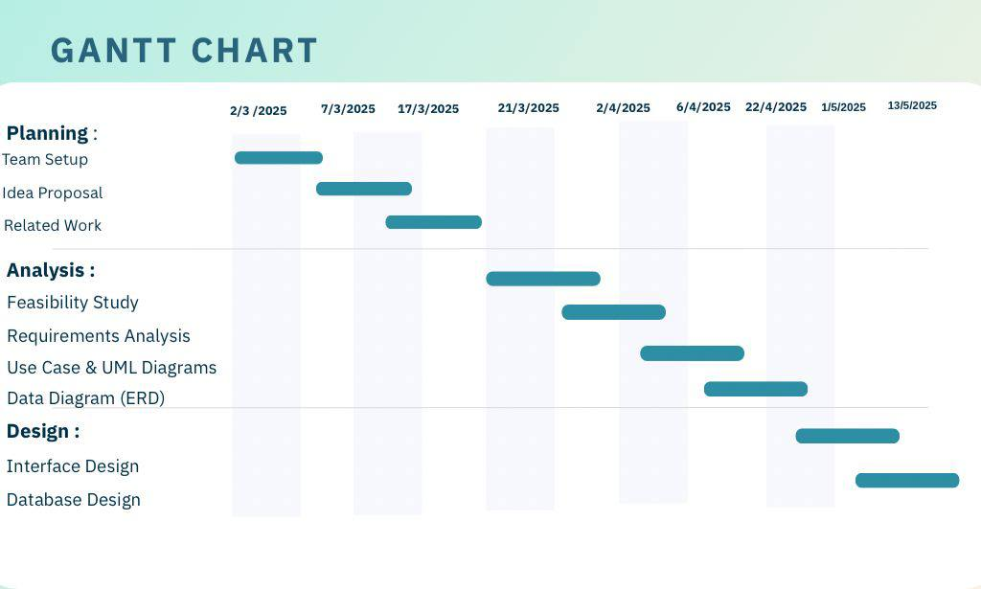

Figure

## Outline

(An overview of your report structure)

# Chapter 2 LITERATURE REVIEW

## Introduction

This chapter aims to present a comprehensive review of the literature and previous studies related to digital systems and platforms designed to streamline the management of recommendation letters. It highlights the most prominent models and technologies that have been utilized in this context, analyzing their effectiveness, strengths, and weaknesses, as well as identifying gaps that have yet to be addressed. This review serves as a crucial step in understanding the broader context in which the “Athar Graduate” project operates, helping to adopt best practices and avoid the pitfalls encountered in earlier initiatives.

Furthermore, the literature review provides insights into current market trends and reveals the level of user acceptance for such systems, along with their impact on the quality of educational outcomes. It also emphasizes the growing role of intelligent tools, integration with cloud services, and user experience (UX)-driven design in enhancing the overall effectiveness of digital solutions in the academic domain.

## Similar Studies

**King Khalid University:**

An electronic system dedicated to King Khalid University students for submitting academic recommendation requests through an online portal. It allows students to send requests and track their status, with some electronic features that help the student monitor the progress of their request. The service aims to support students in obtaining academic and job opportunities while highlighting their academic and skill-based qualifications.

**Advantages:**

* Sends a notification to the student when the request status is updated.
* Includes a dashboard to track the request status.
* The request submission process is electronic.

**disadvantages**:

* No reminder notification is sent to the professor in case of delay, requiring the student to follow up manually.
* Requests cannot be modified after submission; a new request must be submitted, and the student must contact the professor.

**King Faisal University:**

Students at King Faisal University can use an electronic system to transmit requests for academic recommendations to the relevant faculty members via an online portal. By emphasizing their intellectual and personal credentials, the service seeks to assist students in securing academic and employment prospects.

**Advantages**:

* + - requests are sent electronically.

**disadvantages**:

* The lecturer does not receive a reminder notification.
* The student is not notified when the status of their request is changed; manual follow-ups are required.
* Once a request has been filed, it cannot be changed; a new request must be made.
* There isn't a dashboard that shows the status of requests

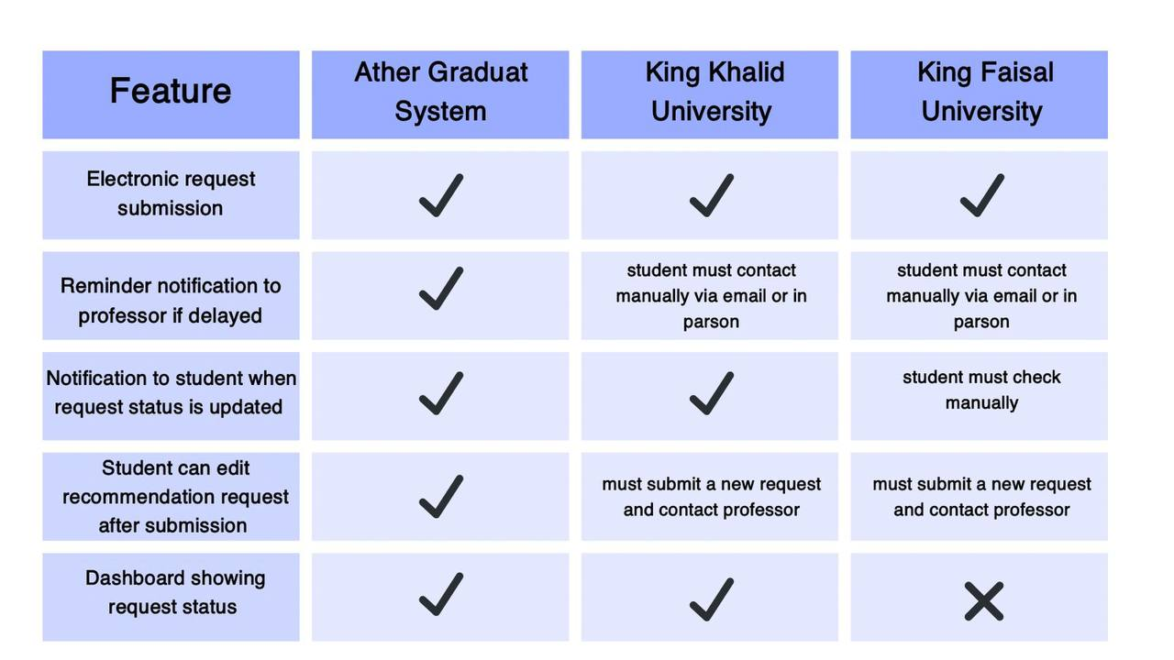.

Figure

Summary

It is clear from examining the literature and earlier research that numerous attempts have been made to create technological solutions that would make the process of requesting and sending recommendation letters easier. While some of these systems offered more comprehensive solutions that included request management, status tracking, and facilitating contact between students and professors, others concentrated only on digitizing recommendation forms. Not all of these endeavors, nevertheless, turned out to be completely successful or realistically dependable. Many have issues with poor user experience, or a lack of clever features.

The necessity for a comprehensive academic system like "Ather Graduate," which provides a single platform that satisfies both academic and technical needs, is one indication of the market gap highlighted in this analysis.

With features including efficient request management, real-time status tracking, and smooth communication between students and staff, this platform aims to enhance the user experience.

Given these conclusions, the "Ather Graduate" project shows promise in resolving the issues with earlier systems. It uses technical integration and clever design approaches to provide a strong platform that is focused on the user. Thus, this study of the literature is an essential first step in creating a new, knowledgeable system founded on practical and scientific understanding.

# Chapter 3 Feasibility Study

## Introduction

Before initiating the development of any system or digital solution, it is essential to conduct a comprehensive feasibility study to evaluate the project’s viability from multiple perspectives. This type of study helps assess the practicality of the proposed solution in terms of operational efficiency, financial capability, legal or ethical compliance, and technical feasibility. It ensures that efforts are directed toward a solution that is realistic, cost effective, and beneficial to all stakeholders, while also supporting informed decision-making. The purpose of the feasibility study for the “Athar Graduate” platform is to evaluate whether developing an intelligent digital system for managing recommendation letters is a practical and effective solution to the current challenges faced by both educators and students. This chapter will examine the project’s technical, operational, and financial aspects. It will assess the availability of the required infrastructure and technology, the ability of intended users to successfully adopt and use the system, and whether the platform can deliver a reasonable return on investment in light of the time, effort, and resources involved. Through this evaluation, the feasibility study aims to help the development team validate the Athar Graduate platform’s ability to meet its objectives and ensure alignment with institutional goals and user needs.

## Operational Feasibility

Operational Operational feasibility examines how well the proposed system can function within the existing academic environment and whether it effectively addresses the identified challenges while meeting users’ expectations. This part of the feasibility study emphasizes the practicality of adopting and using the system by key stakeholders — including students, faculty members, and academic institutions. Currently, the process of requesting and writing recommendation letters is largely unstructured and manual. It often relies on informal communication methods such as emails, face-to-face discussions, or messaging applications. These methods lead to several inefficiencies, including disorganized workflows, delayed responses, missed deadlines, and occasionally lost requests. Additionally, faculty members often face heavy workloads, and without a standardized system, the quality and personalization of the recommendation letters may decline. The Athar Graduate platform seeks to address these issues by offering a digital solution that streamlines the recommendation process. It features structured request forms, customizable templates, automated reminders, and a centralized interface for both students and professors. These elements contribute to a more organized, efficient, and transparent system, improving communication and reducing delays. Moreover, the platform is designed for easy integration into daily academic operations with minimal disruption. Its intuitive interface and adaptable features make it accessible for institutions of various sizes and structures. This level of operational readiness significantly increases the likelihood of successful adoption and consistent use. In conclusion, the Athar Graduate system is highly operationally feasible. It effectively resolves the main challenges identified during the requirements analysis phase, aligns with institutional workflows, and enhances the recommendation process in terms of quality, speed, and reliability.

## Technical Feasibility

The purpose of this section is to evaluate whether the proposed technology and solutions are practical and feasible within the current technical standards. We will assess the tools and technologies to be used for project implementation and whether the required technical expertise is available.

Table

|  |  |
| --- | --- |
| Element | Details |
| Programming Languages | HTML, CSS, JavaScript, PHP – These are the primary technologies used for frontend and backend development. |
| Development Environment | Visual Studio Code – Free, userfriendly development environment. |
| Database Management | MySQL – Secure and flexible storage for user data and recommendation requests. |
| Hosting Servers | Cloud-based hosting to ensure reliability and scalability. |
| Operating Systems | Development will be supported on common systems like Windows |
| Security Tools | SSL/TLS for encryption and JWT for secure sessions. RBAC to manage access. |
| External System Integrations | Optional integration with email notifications or digital signature services. |

## Economic Feasibility

The economic feasibility of the project identifies the expected costs. We found that the technologies used for developing the website (such as HTML, CSS, JavaScript, and PHP) are free and open-source. In addition, the development tools we plan to use, such as Visual Studio Code, are also free, which helps reduce the overall project cost

Table Economic Feasibility – Software Requirements Costs

|  |  |
| --- | --- |
| item | cost |
| HTML, PHP, CSS, JavaScript: Free | Free |
| Visual Studio Code | Free |
| MySQL | Free |

Table Economic Feasibility – Hardware Requirements Cost

|  |  |
| --- | --- |
| item | cost |
| Laptop | 5000 SAR |
| Internet Subscription (1 Year) | 1800 SAR |
| Total Estimated Cost | 6300 SAR |

# Chapter 4 SYSTEM ANALYSIS

## Software Development Methodology

Waterfall Methodology for the Recommendation Management System Development

Using a linear and systematic approach, the Waterfall technique breaks the software development process down into discrete stages. Since it enables clear documentation, structured development, and simple project milestone monitoring, this model was selected for the creation of the Academic Recommendation Management System. Each phase's relevance to this particular project is described below:

1. Requirements: The goals of this first stage were to collect all system requirements from the important parties, such as system administrators, instructors, and students. Functional requirements were determined, including the ability to track the status of requests, manage professor responses, and offer recommendations. Documentation was also done for non-functional needs such system security, usability, and performance standards.

2. Design: The system design was created based on the requirements gathered. This includes developing the platform's architecture, modeling the database structure, and designing user interfaces for administrators, teachers, and graduate students. The system's behavior and data flow were visualized using tools like use case diagrams and ER diagrams.

3. Implementation: Using the design specifications as a guide, the development team started coding the system at this phase. Using the right technologies (e.g., HTML, CSS, PHP, MySQL), features including user registration, login, request submission forms, dashboards, and admin controls were put into place.

4. Testing: To ensure that all requirements were satisfied, the system was put through a rigorous testing process. Usability testing, performance testing, and functional testing (such as request submission and approval) were all part of the testing process to make sure the interface was responsive and easy to use.

5. Deployment: The system was moved to a live hosting environment for demonstration and last-minute assessment after testing was finished successfully and all problems were fixed. The site opened up for interaction with actual people, such as professors and simulated students.

6. Maintenance: The system enters this stage following deployment. User feedback was gathered in order to find any faults or potential areas for improvement. To improve stability and usability and maintain the platform's security and functionality, minor updates and optimizations were made

## Stakeholders Identification

**Graduating students or those nearing graduation** are the primary beneficiaries of the project. They rely on the platform to request recommendations in an organized and professional manner. Their role involves submitting requests and providing academic and personal information that enables faculty members to write accurate and effective letters.

**Faculty members (professors)** are the providers of recommendation letters. Their importance lies in their academic experience and interaction with students, which allows them to write personalized and meaningful recommendations. The platform helps simplify the process by offering tools such as ready-to-use templates and quick access to student information.

**Universities and academic** **institutions** are potential partners in the project, whether through official adoption or integration with their internal systems. Their role is essential in supporting the platform’s use within the educational environment and contributing to enhancing the quality of recommendations issued by the institution.

Finally, the technical support and cybersecurity team plays a vital role in maintaining the system’s security and data protection, ensuring that the platform operates reliably and securely in line with modern technical standards.

## Requirements Gathering and Analyzing

Functional Requirements

* 1. User Registration and Login
* The system must support account creation and login for both Graduate and Professor.
  1. Create Recommendation Request
* Graduates should be able to fill out a form including their academic information, resume, and the target institution.
  1. Send Request to Faculty Member
* The request should be sent directly to the selected professor through the platform.
  1. Student Dashboard
* Allows Graduates to track the status of their requests, edit or cancel them if needed.
  1. professors Dashboard
* Enables professors to review, accept, or reject requests, and generate recommendations using smart templates.
  1. Predefined Recommendation Templates
* The platform should provide editable templates to facilitate the writing process for faculty members.
  1. Notification System
* Sends alerts to both students and faculty about request status, updates, or submission deadlines.
  1. Recommendation Submission
* Allows the recommendation to be sent electronically to the target institution or downloaded in the appropriate format.
  1. Recommendation Archiving
* Stores all submitted recommendations in a secure database for future access by either the student or faculty member.

Non-Functional Requirements

1. Security

* Protect user information and recommendation letters from unauthorized access.

1. Usability

* Provide a simple and user-friendly interface suitable for all types of users (Graduates and Professors).

1. Performance

* Ensure fast loading times and high responsiveness when using the platform.

1. Reliability

* Guarantee stable system performance with minimal downtime or technical errors.

1. Scalability

* Allow the platform to scale in the future to support a larger number of users.

1. Compatibility

* Ensure the platform works across various devices and browsers (mobile, desktop, tablet).

System Analysis

Use Case Diagram

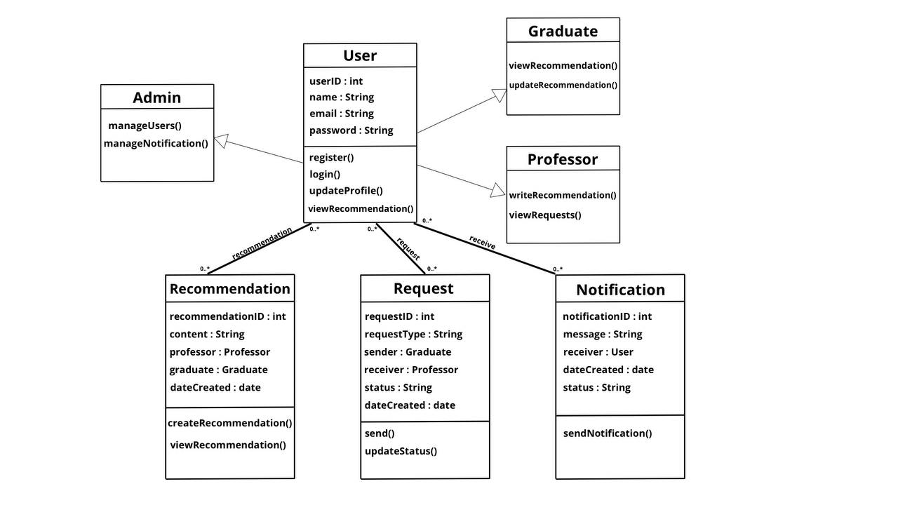

Figure -class

Use case diagram

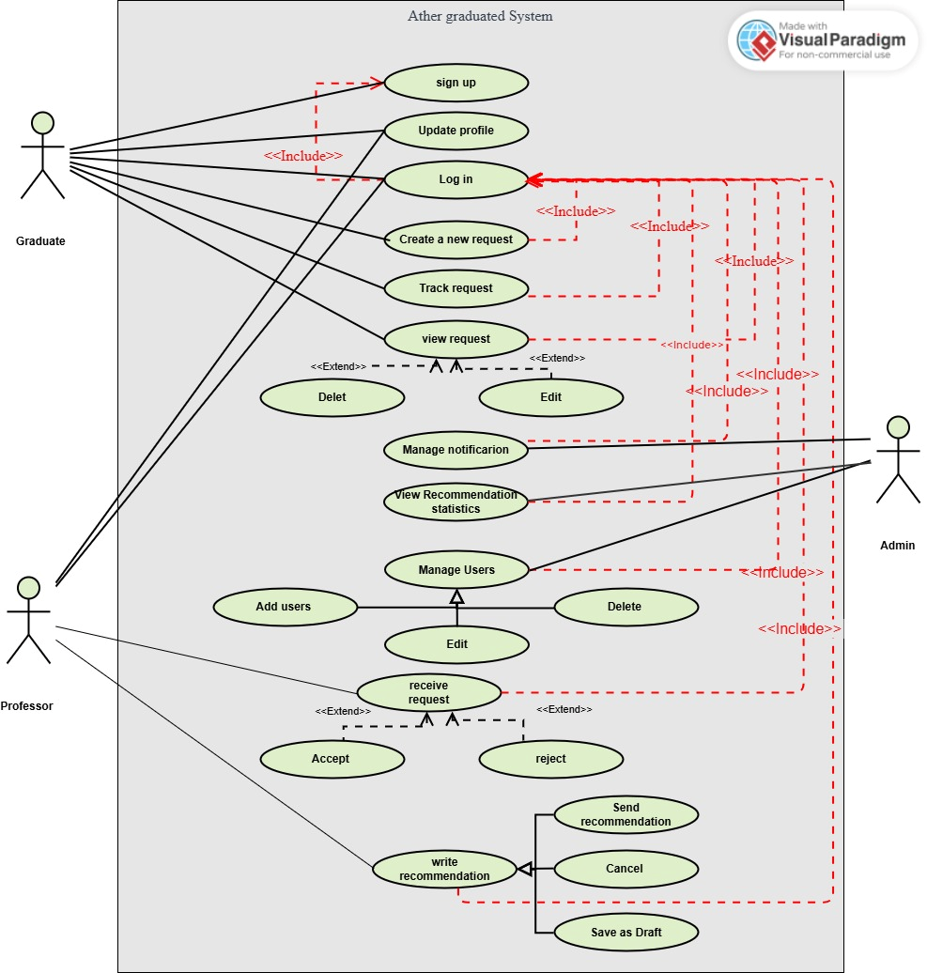

Figure -use case

**Use Case Description: Sign Up**

|  |  |
| --- | --- |
| ID | UC01 |
| Title | Sign Up |
| Description | This use case allows only the graduating student to create a new account in the system by entering their personal and login information. After account creation, the student can access the system and benefit from its services. |
| Primary Actor | Graduating Student |
| Preconditions | The Graduate must not already have an existing account in the system. |
| Postconditions | A new account is successfully created, and the student is redirected to the login page or automatically signed in to their home interface. |
| Main Scenario | 1. The Graduate opens the system.  2. The Graduate selects “Sign Up.”  3. The Graduate enters the required information (full name, university email, Graduate ID, password).  4. The system validates the entered data.  5. The system checks whether the email or Graduate ID is already registered.  6. If the information is valid and unique, the account is created.  7. A success message is shown, and the Graduate is directed to the next step. |
| Alternative Scenarios / Extensions | • If the email or Graduate ID is already in use, the system displays an error message and asks for alternative input.  • If any required information is missing or invalid, the system highlights the errors and requests correction.  • Optionally, the system may send a verification email with an activation link before granting access. |
| Frequency of Use | Used only once when the Graduate creates an account for the first time. |
| Status | Analysis and Design Phase |
| Owner | Ather Graduate development Tea |
| Priority | Very High |

**Use Case Description: Log in**

|  |  |
| --- | --- |
| ID | UC02 |
| Title | Login |
| Description | This case allows the user (graduating student, doctor, or admin) to log into the system using their previously registered credentials to access the services designated for them. |
| Primary Actor | User (Graduate, Professor, admin) |
| Preconditions | The user must have a previously registered account in the system. |
| Postconditions | The user is directed to the appropriate main interface based on their role after successful login verification. |
| Main Scenario | 1.The user opens the system.  2.The user selects “Login.”  3.The user enters the username and password. 4.The system verifies the accuracy of the credentials.  5.The user is logged in and directed to their main page. |
| Alternative Scenarios / Extensions | -If the user does not have an account, they are directed to the “Sign Up ” use case. -If the login credentials are incorrect, the system displays an error message and prompts the user to try again. |
| Frequency of Use | It is used every time the user needs to log into the system. |
| Status | Analysis and Design Phase |
| Owner | Ather Graduate development Tea |
| Priority | Very High |

**Use Case Description: New order**

|  |  |
| --- | --- |
| ID | UC03 |
| Title | New order |
| Description | This use case allows the Graduate to create a new recommendation request from a professor for a specific course or academic topic. |
| Primary Actor | Graduating Student |
| Preconditions | -The Graduate must be logged into the system.  -The Graduate must be connected to the internet |
| Postconditions | The request data is updated if modified, or removed from the system if canceled. |
| Main Scenario | 1. Graduate logs into the system. 2. Navigates to 'My Requests' page. 3. Selects the request to be modified or canceled. 4. If modifying: updates the required data and clicks 'Save'. 5. If canceling: clicks 'Cancel Request' and confirms the action. 6. A success confirmation message is displayed. |
| Alternative Scenarios / Extensions | - If the Graduate has no existing requests, a message indicating this is displayed. - If incorrect data is entered during modification, an error message appears and a retry is requested. |
| Frequency of Use | Available whenever the Graduate needs to modify or cancel their request. |
| Status | Analysis and Design Phase |
| Owner | Ather Graduate development Tea |
| Priority | Very High |

**Use Case Description: Track request**

|  |  |
| --- | --- |
| ID | UC04 |
| Title | Track request |
| Description | This use case enables the Graduate to track the-status of a previously submitted recommendation request, providing visibility into whether the request has been approved, is under review, or has been rejected |
| Primary Actor | Graduating student |
| Preconditions | -The Graduate must be logged into the system.  -The Graduate must be connected to the internet |
| Postconditions | - The recommendation request is sent to the professor.  - The Graduate is notified that the request has been successfully submitted.  - The professor is notified of the new request. |
| Main Scenario | 1. The Graduate logs into the system.  2. The Graduate selects “New order”.  3. The Graduate selects the course.  4. The Graduate selects the professor.  5. The Graduate fills out the request form.  6. The Graduate clicks “Submit Request”.  7. A notification is sent to the professor. |
| Alternative Scenarios / Extensions | - If the Graduate has no registered courses with the selected professor, the system displays a message indicating that the request cannot be submitted.  - If there is a connection or network issue, the system displays an error message and asks the Graduate to try again.  - If the professor is unavailable or not registered in the system, they will not appear in the selection list |
| Frequency of Use | Each time the Graduate needs to submit a recommendation request |
| Status | Analysis and Design Phase |
| Owner | Ather Graduate Development Team |
| Priority | Very High |

**Use Case Description: View request**

|  |  |
| --- | --- |
| ID | UC05 |
| Title | View request |
| Description | This use case allows the Graduate to modify previously entered recommendation request data in the system or cancel the request entirely when needed |
| Primary Actor | Graduating student |
| Preconditions | The Graduating student must have a previously submitted recommendation request in the system. |
| Postconditions | The request data is updated if modified, or removed from the system if canceled. |
| Main Scenario | 1. Graduate logs into the system.  2. Navigates to 'My Requests' page.  3. Selects the request to be modified or canceled.  4. If modifying: updates the required data and clicks 'Save'.  5. If canceling: clicks 'Cancel Request' and confirms the action.  6. A success confirmation message is displayed. |
| Alternative Scenarios / Extensions | - If the Graduate has no existing requests, a message indicating this is displayed.  - If incorrect data is entered during modification, an error message appears and a retry is requested. |
| Frequency of Use | Available whenever the Graduate needs to modify or cancel their request. |
| Status | Analysis and Design Phase |
| Owner | Ather Graduate Development Team |
| Priority | Very High |

**Use Case Description: Write Recommendation**

|  |  |
| --- | --- |
| ID | UC09 |
| Title | Write Recommendation |
| Description | This use case allows the professor to write a personalized recommendation letter in response to an approved request from a student for a specific academic purpose |
| Primary Actor | Professor |
| Preconditions | • The professor must be logged into the system.  • The recommendation request must be approved.  • The professor must have access to the student’s academic details. |
| Postconditions | The request data is updated if modified, or removed from the system if canceled. |
| Main Scenario | 1. The professor logs into the system.  2. The professor navigates to the “Approved Requests” section.  3. The professor selects a specific student’s request.  4. The system displays a recommendation template or an empty editor.  5. The professor writes the recommendation letter content.  6. The professor saves the recommendation.  7. The system confirms that the recommendation has been saved successfully. |
| Alternative Scenarios / Extensions | - If the professor exits without saving, the system prompts to save or discard the draft.  - If the Graduate’s academic data is incomplete, the system displays a warning and may prevent submission.  - If the professor tries to access a non-approved request, the system shows an access restriction message. |
| Frequency of Use | Each time a professor writes a recommendation for an approved Graduate request. |
| Status | Analysis and Design Phase |
| Owner | Ather Graduate Development Team |
| Priority | Very High |

Context Diagram (or Basic class diagram) to describe the context of your project).

System Sequence Diagrams (SSD)

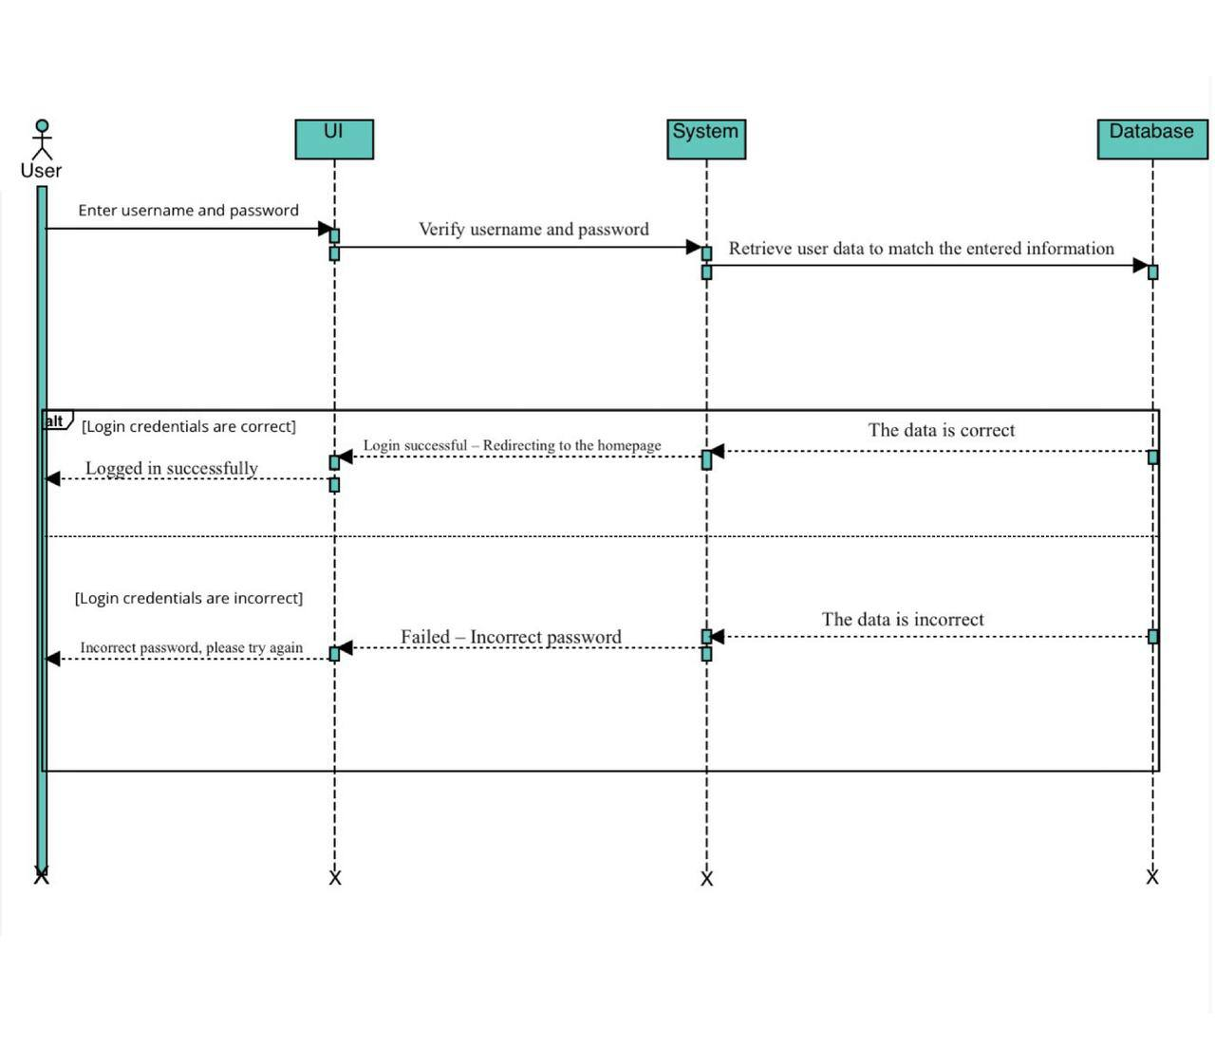

Figure

Figm2

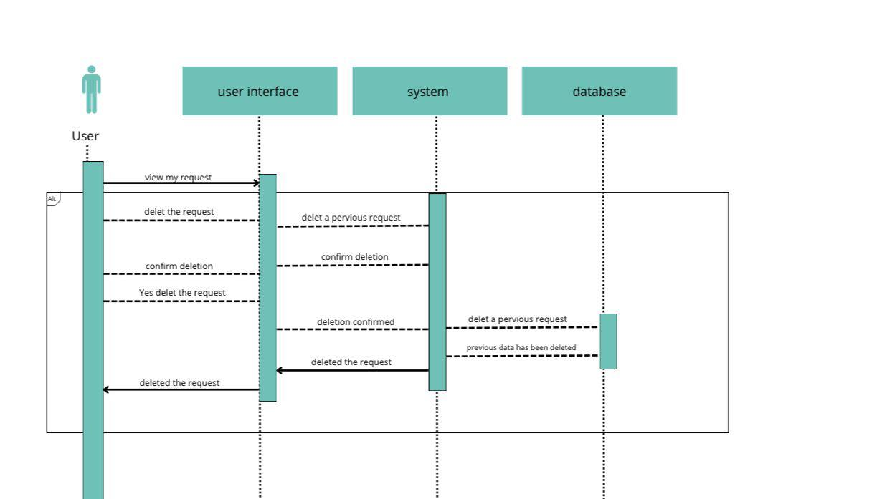

Figure

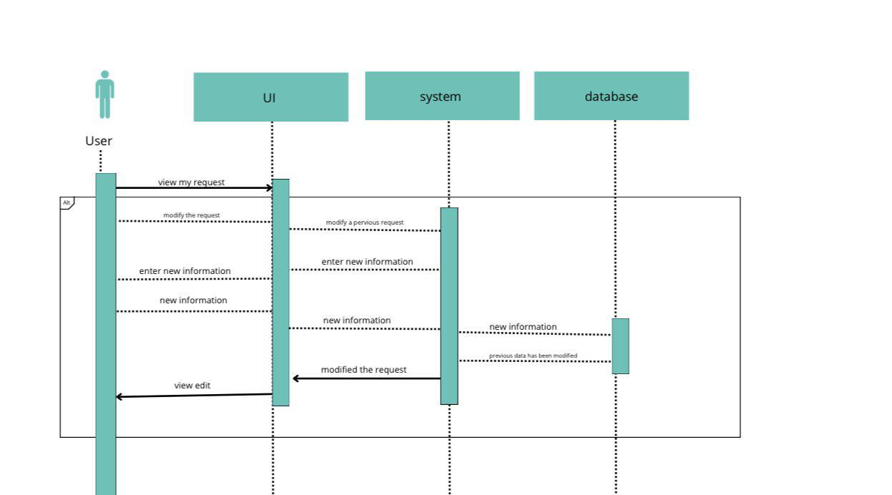

Figure

## Summary

………

# Chapter 5 System Design

## Detailed System Design and component descriptions

Components Description (use one of the architecture design patterns or UML component diagram to illustrate the components of your proposed system)

Sequence Diagrams (SQD) to describe the detailed interaction between objects in each use case.

Activity Diagram to describe the different activities and related actions of your system.

## Database Design

Use UML class diagram with more details describing classes, their attributes and methods, and the detailed relationships between them.

You can also use ERD diagram to indicate the primary and secondary keys for each entity. This will help you later to implement your database.

Show how your database is built using SQL oracle.

## User Interface Design

Use any tools to describe user interfaces for your system and show the logic of moving from one interface to another.

## Summary

………

# Chapter 6 Implementation and Testing plan

## Implementation Plan

Give a proposal of how you will transform your models and designs to actual implementation (code): what tools you will use, what programming languages you will use, how you will do.

## Testing Plan

Give a proposal of how you will test your system: You can describe how you will conduct unit, integration, and system testing. Also, if you will use specific tools, describe them here.

## Summary

………

# Chapter 7 Conclusion

## Introduction

Summary of what you did and what you learned. Also, provide the limitations of your work if you have any.

## Future Work

………

# List of References

<You should follow a suitable format (APA, MLA, etc.) for writing the list of references.>

…….

# Appendix A

<Here you can put any extra materials such as figures, or illustrations of the results, samples of surveys, interviews.>

………………..